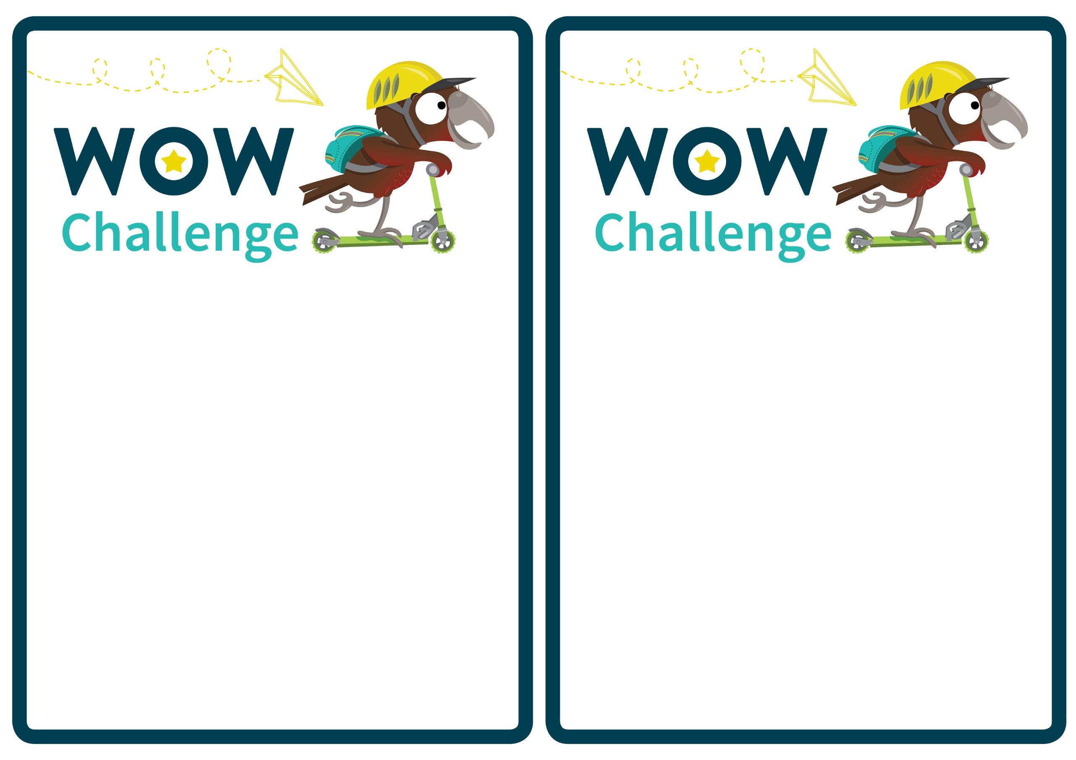

**Dear Parent/Caregiver,**

Research shows that getting active on the way to school can improve children’s independence, confidence, road and personal safety skills and general health and wellbeing.

To encourage active travel, our school is running a Walk or Wheel Challenge.

**What is Walk or Wheel?**

Walk or Wheel (WOW) aims to encourage students to walk, cycle, scoot or skateboard to and from school.

**Rewards**

Participating students will complete a special Walk or Wheel Passport and receive small rewards for their efforts.

They may even go into a draw for bigger prizes at the end of the term!

**But we live too far from school to walk…**

Try driving part way to school and walking the last 5 minutes. This reduces congestion at the school gate and enables your children to get active and take part in Walk or Wheel.

**Dear Parent/Caregiver,**

Research shows that getting active on the way to school can improve children’s independence, confidence, road and personal safety skills and general health and wellbeing.

To encourage active travel, our school is running a Walk or Wheel Challenge.

**What is Walk or Wheel?**

Walk or Wheel (WOW) aims to encourage students to walk, cycle, scoot or skateboard to and from school.

**Rewards**

Participating students will complete a special Walk or Wheel Passport and receive small rewards for their efforts.

They may even go into a draw for bigger prizes at the end of the term!

**But we live too far from school to walk…**

Try driving part way to school and walking the last 5 minutes. This reduces congestion at the school gate and enables your children to get active and take part in Walk or Wheel.