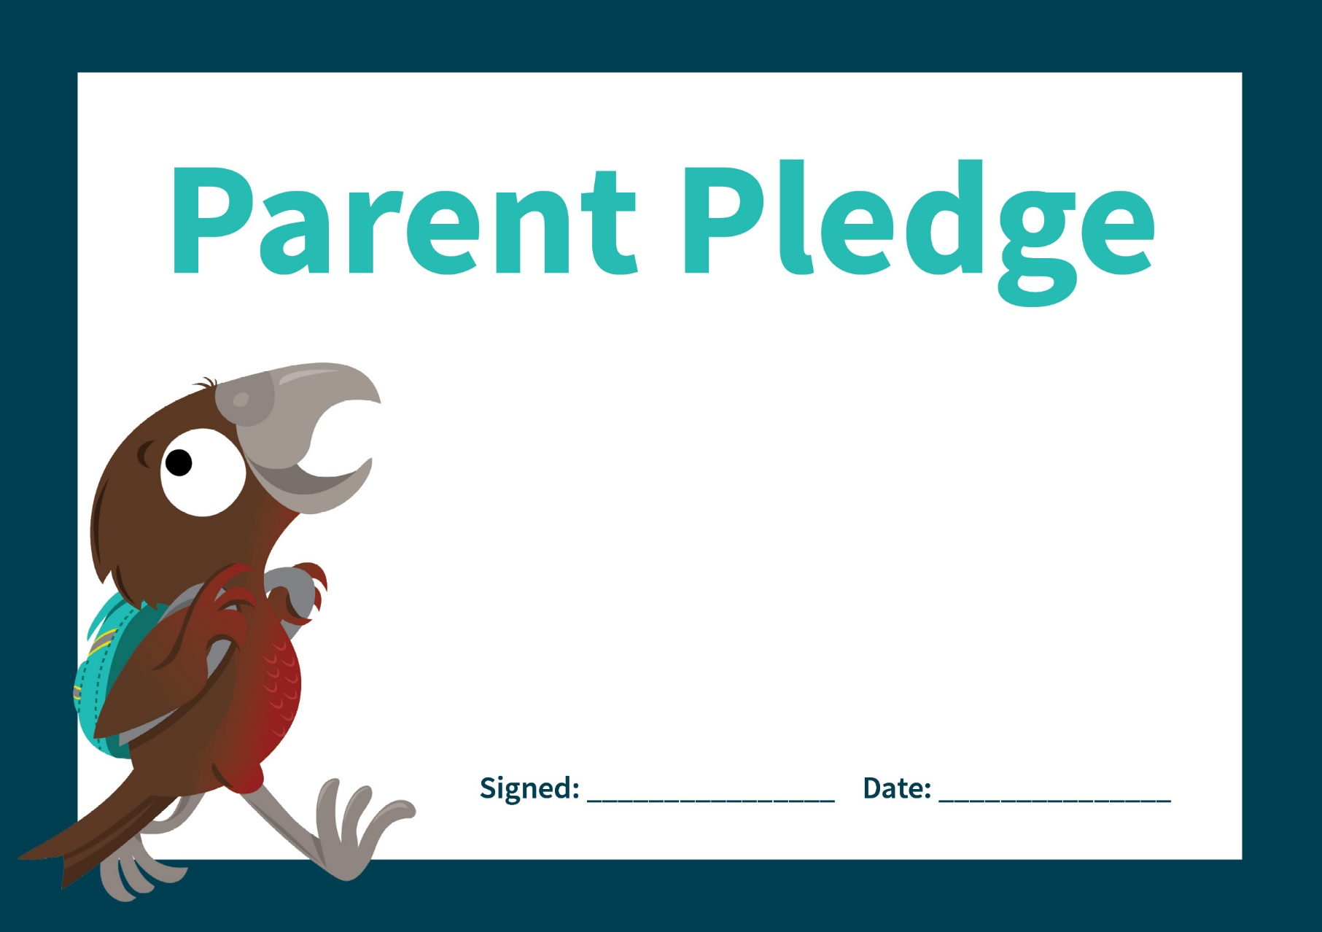

I PROMISE TO:

1. Allow my children to walk or wheel when possible
2. Use alternative drop-off points
3. Slow down when driving near the school
4. Not park on yellow-lines or over driveways
5. Not do u-turns near the school
6. Stop at pedestrian crossings

I PROMISE TO:

1. Allow my children to walk or wheel when possible
2. Use alternative drop-off points
3. Slow down when driving near the school
4. Not park on yellow-lines or over driveways
5. Not do u-turns near the school
6. Stop at pedestrian crossings